# **Montana State Council**

**Affiliate of the Society for Human Resource Management**

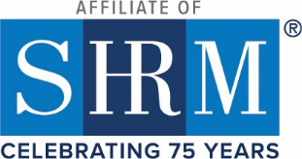

 ***LEGISLATIVE UPDATE***

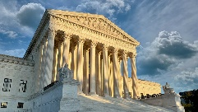 ***FEBRUARY 2025 UPDATE***



|  |
| --- |
| Grover Wallace – Montana State Legislative Director |
|  |

**FMLA Leave Rights Are Available for Some Sibling Relationships**

February 13, 2025 | Linda B. Hollinshead and Anshul S. Agrawal

**Takeaway:** This case illustrates that an employee may be eligible for FMLA leave to care for an adult sibling or other adult dependents when the employee demonstrates the intention to serve as a parent. Therefore, managers and leave administrators should be aware that employees’ requests to care for adult siblings and other dependents should not be rejected without further confirmation—consistent with the FMLA’s certification requirements—of the status of the relationship. Similarly, employers should be aware of and comply with more expansive state and local leave laws. For example, the New Jersey Family Leave Act provides unpaid leave to care for “family members,” defined more broadly to also include a parent-in-law, sibling, grandparent, grandchild, domestic partner, or civil union partner, among other relationships.

**SHRM LINK ARTICLE:** [FMLA Leave Rights Are Available for Some Sibling Relationships](https://www.shrm.org/topics-tools/employment-law-compliance/fmla-leave-rights-are-available-some-sibling-relationships?utm_placement=article4&utm_source=marketo&utm_medium=email&utm_campaign=editorial~compliance_topical~NL_2025-02-21_Workplace-Compliance&linktext=FMLA-Leave-Rights-Are-Available-for-Some-Sibling-Relationships&mktoid=49915738&mkt_tok=ODIzLVRXUy05ODQAAAGYyKjNaTb98GwPf8unr9EXLh0WrZSYAEb9Wfk9tQF82ISxykSzXw4qDXKAU5tDl4Poq7tO9FI4pfqCRm1km0sWbqeCy7XPebEb43VdEvsjW1n1M4m7)

**January’s DEI Executive Orders Will Have Impact for Years to Come**

February 13, 2025 | [Allen Smith, J.D.](https://www.shrm.org/about/bio/allen-smith)

Two recent diversity, equity, and inclusion (DEI) executive orders (EOs) will have a far-reaching impact on the federal government and the private sector, speakers said during a Feb. 12 SHRM webcast, “Diving Deeper into Affirmative Action and Federal Contractor Compliance: Key Insights and Critical Actions.”

**Jan. 20 Executive Order**

The first EO, which President Donald Trump issued Jan. 20, is titled “[Ending Radical and Wasteful Government DEI Programs and Preferencing](https://www.whitehouse.gov/presidential-actions/2025/01/ending-radical-and-wasteful-government-dei-programs-and-preferencing/).” It requires the director of the Office of Management and Budget (OMB), assisted by the attorney general and the director of the Office of Personnel Management (OPM), to “coordinate the termination of all discriminatory programs.” That includes “illegal DEI and ‘diversity, equity, inclusion, and accessibility’ (DEIA) mandates, policies, programs, preferences, and activities in the federal government, under whatever name they appear.”

To carry out this directive, the OPM’s director, with the assistance of the attorney general, was ordered to review and revise all existing federal employment practices, union contracts, and training policies or programs to comply with the EO. “Federal employment practices, including federal employee performance reviews, shall reward individual initiative, skills, performance, and hard work and shall not under any circumstances consider DEI or DEIA factors, goals, policies, mandates, or requirements,” the order said.

**Jan. 21 Executive Order**

The next day, Trump issued another sweeping [executive order](https://www.shrm.org/topics-tools/employment-law-compliance/how-to-adjust-dei-initiatives-under-trumps-new-guidelines), titled “[Ending Illegal Discrimination and Restoring Merit-Based Opportunity](https://www.whitehouse.gov/presidential-actions/2025/01/ending-illegal-discrimination-and-restoring-merit-based-opportunity/).”

This EO did many things, including revoking Executive Order 11246, which had required federal contractors to practice [affirmative action](https://www.shrm.org/topics-tools/employment-law-compliance/trump-rescinds-affirmative-action-by-contractors-race-gender) based on race and gender. Federal contractors have a 90-day grace period in which they can continue to comply with EO 11246. But the Office of Federal Contract Compliance Programs within the U.S. Department of Labor was ordered to immediately cease taking several steps, including holding federal contractors and subcontractors responsible for taking affirmative action.

**SHRM LINK ARTICLE:** [January’s DEI Executive Orders Will Have Impact for Years to Come](https://www.shrm.org/topics-tools/employment-law-compliance/january-dei-executive-orders-will-have-impact-years-to-come?utm_placement=article1&utm_source=marketo&utm_medium=email&utm_campaign=editorial~compliance_topical~NL_2025-02-21_Workplace-Compliance&linktext=Januarys-DEI-Executive-Orders-Will-Have-Impact-for-Years-to-Come&mktoid=49915738&mkt_tok=ODIzLVRXUy05ODQAAAGYyKjNaROxX6CuO2w54mFXftEC69jh2RrCHQBBSzZNZ9Ih1WvKePgnbyXO2d2NBxxxP6f1PoY4bGD7sSRRUkiun9xCUJehxcSwUgUDTOPBhJymYuG2)

**NLRB General Counsel Memos from the Biden Administration Revoked**

February 18, 2025 | [Allen Smith, J.D.](https://www.shrm.org/about/bio/allen-smith)

Many of the National Labor Relations Board (NLRB) general counsel (GC) memos issued during the Biden administration were rescinded on [Feb. 14](https://www.nlrb.gov/news-outreach/news-story/gc-25-05-rescission-of-certain-general-counsel-memoranda), easing burdens on employers.

Rescinded memos include:

* GC 21-08 Statutory Rights of Players at Academic Institutions (Student-Athletes) Under the National Labor Relations Act (NLRA).
* GC 22-06 Update on Efforts to Secure Full Remedies in Settlements (Revised Attachment).
* GC 23-02 Electronic Monitoring and Algorithmic Management of Employees Interfering with Section 7 Rights.
* GC 23-08 Noncompete Agreements that Violate the NLRA.
* GC 24-04 Securing Full Remedies for All Victims of Unlawful Conduct.
* GC 25-01 Remedying the Harmful Effects of Noncompete and ‘Stay-or-Pay’ Provisions that Violate the NLRA.

In addition, many memos were rescinded pending further guidance, including:

* GC 21-06 Seeking Full Remedies.
* GC 24-01 (Revised) Guidance in Response to Inquiries About the Board’s Decision in *Cemex Construction Materials Pacific LLC*.
* GC 25-04 Harmonization of the NLRA and EEO Laws.

**SHRM LINK ARTICLE:** [NLRB General Counsel Memos from the Biden Administration Revoked](https://www.shrm.org/topics-tools/employment-law-compliance/nlrb-general-counsel-memos-from-biden-administration-revoked?utm_placement=article3&utm_source=marketo&utm_medium=email&utm_campaign=editorial~compliance_topical~NL_2025-02-21_Workplace-Compliance&linktext=NLRB-General-Counsel-Memos-from-the-Biden-Administration-Revoked&mktoid=49915738&mkt_tok=ODIzLVRXUy05ODQAAAGYyKjNaXygTdsfapZEwuLHVR-g5YQfP4HkWX8fuBDP1lRiFlLHd9rgJmSJKgL03bU8-DwJJzABt86wklHhzn_4A4v2vhJGswsToBGrakKW7madz-_b)

**Title VII Refresher in Light of Possible Criminal Investigations**

February 7, 2025 | [Allen Smith, J.D.](https://www.shrm.org/about/bio/allen-smith)

Compliance with [Title VII of the Civil Rights Act of 1964](https://www.shrm.org/topics-tools/tools/toolkits/managing-equal-employment-opportunity) is more important now than ever, as equal employment opportunity efforts are being scrutinized more closely following President Donald Trump’s [diversity, equity, and inclusion (DEI) executive orders](https://www.shrm.org/topics-tools/employment-law-compliance/how-to-adjust-dei-initiatives-under-trumps-new-guidelines). Concern among companies also has been heightened by a Feb. 5 U.S. Department of Justice (DOJ) [memo](https://www.justice.gov/ag/media/1388501/dl?inline) considering criminal investigations of illegal programs.

Title VII prohibits discrimination based on race, color, national origin, sex (including [sexual orientation and gender identity or expression](https://www.shrm.org/topics-tools/employment-law-compliance/supreme-court-says-federal-anti-bias-law-protects-lgbtq-workers)), and religion. Title VII applies to employers with 15 or more employees, each working 20 or more weeks in the current or preceding calendar year; state and local government; employment agencies; labor unions; and U.S. citizens employed by U.S.-owned or controlled companies in foreign countries.

**SHRM LINK ARTICLE:** [Title VII Refresher in Light of Possible Criminal Investigations](https://www.shrm.org/topics-tools/employment-law-compliance/title-vii-refresher-light-of-possible-criminal-investigations?utm_placement=article2&utm_source=marketo&utm_medium=email&utm_campaign=editorial~hrd_flag~NL_2025-02-14_HR-Daily-Roundup&linktext=Title-VII-Refresher-in-Light-of-Possible-Criminal-Investigations&mktoid=49915738&mkt_tok=ODIzLVRXUy05ODQAAAGYpDlDa3tKvneanl7UZi4dcoymcBIz38VXD0h1F5rBlSbpCZ6BDdmDFxpD7a11A12M11VICJn4oTuZd9qA_B-lz_dopuifyybfdcKA0P52K9k0GQHJ)

**MONTANA STATE LEGISLATIVE SESSION**

Here are a few employment related bills pending this legislative session.

**HB 245 - Revise the Montana HELP Act workforce development provisions and termination date**

**HOUSE BILL NO. 245 2 INTRODUCED BY E. BUTTREY, E. ALBUS, C. SCHOMER, D. BEDEY**

The bill aims to revise the workforce development provisions under the Healthy Montana Health and Economic Livelihood Partnership Act by removing the requirement for contracting with private entities for training and education programs. It amends Section 39-12-103 of the Montana Code Annotated (MCA) to allow individuals receiving healthcare assistance to participate in an employment or reemployment assessment as part of the workforce development program. The assessment will identify barriers to employment, and the department will assist participants in completing it and provide necessary workforce development services based on the assessment results.

**CURRENT STATUS:** Passed in House chamber, now in Senate Committee – Senate Finance & Claims hearing Feb. 25th

**HB 484 – Providing for an increase in the minimum wage**

A BILL FOR AN ACT ENTITLED: “AN ACT PROVIDING FOR AN INCREASE IN THE MINIMUM WAGE; REMOVING A $4 MINIMUM WAGE FOR CERTAIN BUSINESSES; AMENDING SECTION 39-3-409, MCA; AND PROVIDING AN EFFECTIVE DATE.”

Section 1. Section 39-3-409, MCA, is amended to read: "39-3-409. Adoption of minimum wage rates -- exception. (1) The minimum wage, except as provided in subsection (3), must be the greater of either: (a) the minimum hourly wage rate as provided under the federal Fair Labor Standards Act of 1938 (29 U.S.C. 206(a)(1)), excluding the value of tips received by the employee and the special provisions for a training wage; or (b) $6.15 $12.06 an hour, excluding the value of tips received by the employee and the special provisions for a training wage. (2) (2)(b). (b) (a) The minimum wage is subject to a cost-of-living adjustment, as provided in subsection No later than September 30 of each year, an adjustment of the wage amount specified in subsection (1) must be made based upon the increase, if any, from August of the preceding year to August of the year in which the calculation is made in the consumer price index, U.S. city average, all urban consumers, for all items, as published by the bureau of labor statistics of the United States department of labor.

**CURRENT STATUS:** Referred to House Business and Labor committee Feb. 13, 2025, tabled.

**HB 367: Revise workers' compensation laws relating to travel and reimbursement**

**INTRODUCED BY E. BUTTREY, R. MARSHALL**

A BILL FOR AN ACT ENTITLED: “AN ACT REVISING WORKERS' COMPENSATION LAWS RELATING TO TRANSPORTATION; PROVIDING THAT WHETHER AN EMPLOYER FURNISHES TRANSPORTATION OR THE EMPLOYEE RECEIVES CERTAIN REIMBURSEMENT FROM THE EMPLOYER IS NOT DISPOSITIVE OF WHETHER THE EMPLOYEE IS COVERED FOR WORKERS' COMPENSATION INSURANCE; AMENDING SECTION 39-71-407, MCA; AND PROVIDING AN APPLICABILITY DATE.” BE IT ENACTED BY THE LEGISLATURE OF THE STATE OF MONTANA:

**CURRENT STATUS:** First reading in Senate.

**HB 297: Healthy Families and Workplace Act – Providing for paid Sick Leave.**

INTRODUCED BY S. HOWELL, J. ISALY, T. CROWE, J. SECKINGER, S. FYANT, C. NEUMANN, SOOKTIS, E. MATTHEWS, J. MORIGEAU, J. WINDY BOY, M. CAFERRO, T. FRANCE, D. HAWK, K. KORTUM, A. OLSEN, E. STAFMAN

A BILL FOR AN ACT ENTITLED: “AN ACT REVISING LAWS RELATED TO PAID SICK LEAVE; CREATING THE HEALTHY FAMILIES AND WORKPLACES ACT

Section 2. Purpose. The legislature declares that it is the purpose of the Healthy Families and Workplaces Act to: (1) (2) safeguard the public health, safety, and welfare; and establish minimum paid sick leave standards for employees at levels consistent with their health, efficiency, and general well-being.

**CURRENT STATUS:** House – Tabled in committee.

***UPCOMING CALENDAR EVENTS:***

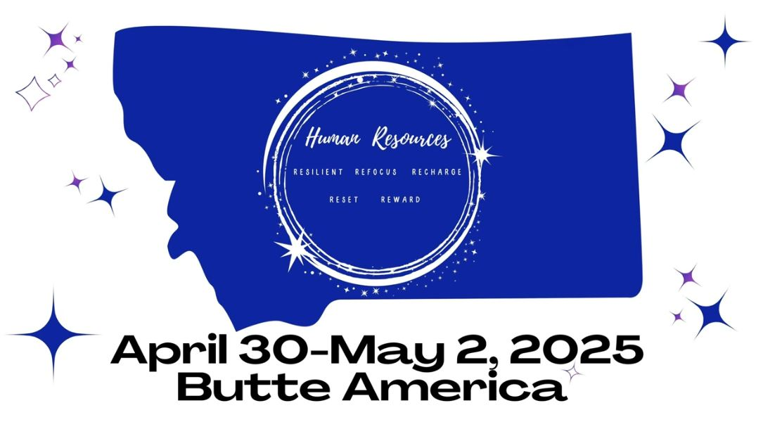

Montana's premiere Human Resource Conference.

2025 Conference Registration is open.  
Early Bird pricing ends January 31, 2025

[**Register to attend Today!**](https://lp.constantcontactpages.com/ev/reg/ywktega/lp/8b7c5398-9d04-4e16-adae-f4be02cbe88c)

**UPCOMING SHRM WEBINARS**

**MARCH 5 | 1 P.M. ET | 10 A.M. PT**  
[50 Days In: Policy Changes, Workforce Impact,  
and How HR Can Respond](https://c.shrm.org/ODIzLVRXUy05ODQAAAGY3FKmYXc52_jE_Svo7X5lJ7DqcuzZhyKogk_Q0Txj-5M4upbfxuTGIwSA2ynQdCtYKkBz5Yo=)

**MARCH 12 | 1 P.M. ET | 10 A.M. PT**  
[Your Questions Answered:  
Executive Orders and Compliance](https://c.shrm.org/ODIzLVRXUy05ODQAAAGY3FKmYIkqCDCr3L556Q96b1KKiLrRFnm2edgnuGfHpfIJCahJWJD3SpK3BpxDzxCBdOGwkuY=)

***THANK YOU***